# The Scotese method for paleo-temperature reconstruction over the Phanaeorozoic

Alex Skeels and Thomas Keggin

## Data sources

**Long term climatic indicators (50-100myr) - Koppen Bands**

Derived from fossil and lithological indicators from Boucot et al (2013) amongst other sources.

5 Myr intervals from 540 Ma

These come as cleaned Jpegs – done by Oskar Hagen – and are saved as .asc files (LOCATION)

**Medium-term climatic indicators (5-10Myr) - oxygen isotopes**

Change in temperature in tropical oceans is derived from oxygen isotope ratios in calcareous deposits (from reefs, shells, etc). Scotese uses Song et al 2019 temperature curve from oxygen isotope ratios as the most recent (at the time) estimates of changes in temperatures in tropical oceans.

**Short-term climatic indicators (1Myr) – event indicators**

There are known events that occur on much shorter timescales and leave imprints in bio-geological signal. For example, bolide impacts etc. for indicating global events such as the K/Pg meteor impact. Scotese makes a number of manual changes to the temperature curve of Song et al. based on these known events. These changes are detailed in the Scotese review. These changes can also be seen in the following curve, showing the change in tropical temperature (Delta Ttrop).

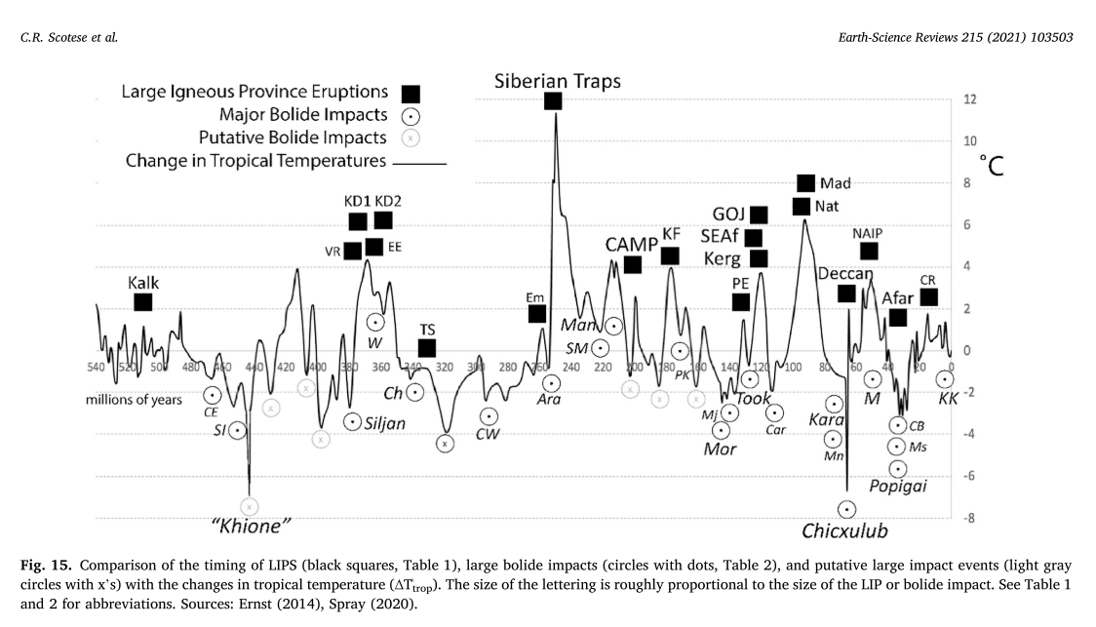

In the supplementary material for Scotese’s paper, “Part 4. Phanerozoic_Paleotemperature_Summaryv4”, on page 1my, the column Tropical – 26 (the average temperature for tropical Koppen band) will give this curve.

As follows:

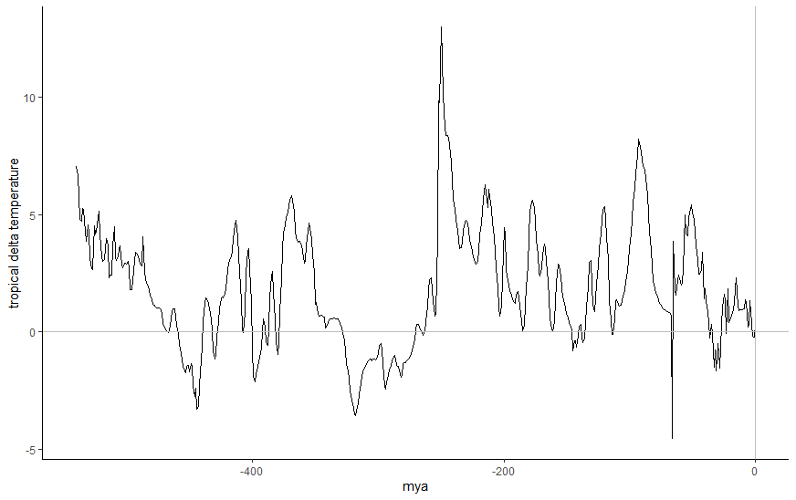

## Combining data to create global temperature maps

Scotese estimates global average temperature from the change in the distribution of Koppen bands across the Phanerozoic. He first gives each Koppen band a value of modern temperature (Legates and Wilmott 1990) then estimates global averaging by finding the average temperature weight by the area of each band. This is the GAT curve from Scotese 2021 (below).

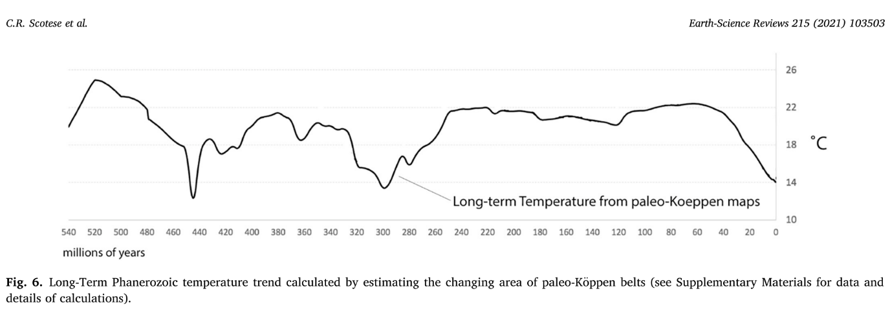

While this curve is meant to reflect long term changes in global temperature, it misses much fine scale resolution information contained in other data sources such as the oxygen isotope record. So based on the temperature curve for tropical oceans and the koppen bands, we change global temperatures using Delat Ttrop.

Delta Ttrop = the tropical temperature estimates – 26 (the average temperature for the tropical belt)

If we add Delta Ttemp to each of the Koppen tmperatures then we can adjust the GAT from the Koppen bands to account for more fine scale changes in global temperatures.

This gives us the following curve:

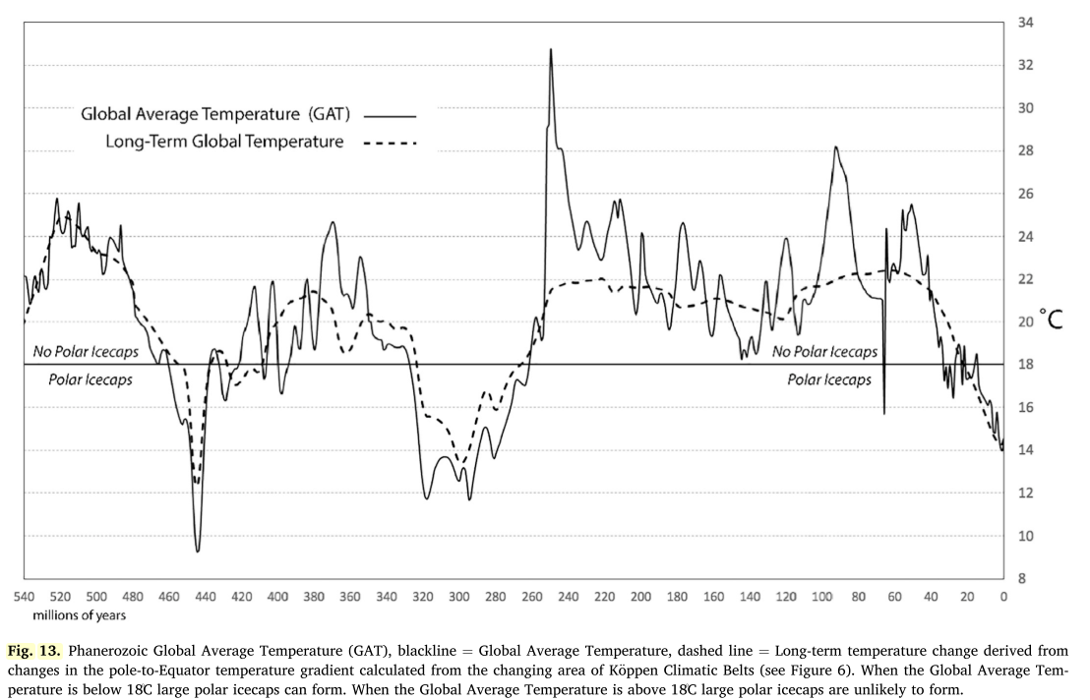

**References**

Boucot, A.J., Chen Xu, and Scotese, C.R, 2013. Phanerozoic Paleoclimate: An Atlas of Lithologic Indicators

of Climate, SEPM Concepts in Sedimentology and Paleontology, (Print-on-Demand Version), No. 11, 478 pp., ISBN 978-1-56576-289-3, October 2013, Society for Sedimentary Geology, Tulsa, OK

Legates, D.R., Willmott, C.J. 1990. Mean seasonal and spatial variability in global surface air temperature. Theoretical and Applied Climatology, 41 (1-2), pp. 11-21.

Scotese, C. 2021. Phanerozoic paleotemperatures: The earth’s changing climate during the last 540 million years. Earth Science Reviews.

Song, H., Wignall, P.B., Song, H., Dai, X., Chu, D., 2019. Seawater temperature and dissolved oxygen over the past 500 million years. Journal of Earth Sciences 30 (2), 236–243.